             **Name**   : SAFRIZAL RAHMAN

           ` **Nim**      : 2341760151

**Kelas**    : 1-G

**Number :** 22

**Materi**  : Fungsi 1

**BASIC PROGRAMMING PRACTICUM REPORT  
  
Github Project:** [**https://github.com/NaufalArdian12/Tugas_Akhir_Java_Semester1**](https://github.com/NaufalArdian12/Tugas_Akhir_Java_Semester1)

**Github Name:** <https://github.com/safrizalrahman46> **Github Jobsheet:**   
<https://github.com/safrizalrahman46/Jobsheet13>

**1JOBSHEET 10**

**Function 1**

# 1. Learning Outcome

After finishing this lesson, students must be able to:

1. Master the basic concept of function, function parameter, return value, and scope of variable.
2. Implement Java program to create function, as well as for function with parameter, without parameter, with return value, without return value, and to call the function.

# 2. Labs Activity

## 2.1 Experiment 1: Function Without Parameter Time: 40 minutes

1. Create a new class and save it as **Gratitude_StudentIDNumber.java**.
2. Create a function named **sayThankyou()** in the class.



1. Create **main()** function and call **sayThankyou()** function from main function..

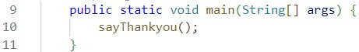

*/\*\**

*\* Gratitude22*

*\*/*

public class Gratitude22 {

    public static void sayThankyou() {

    System.out.println("Thank ypu for being the best teacher in the world\n"+

    "You inspired in me a love for learning and made me feel like i could ask you anything");

    } public static void main(String[] args) {

        sayThankyou();

}

}

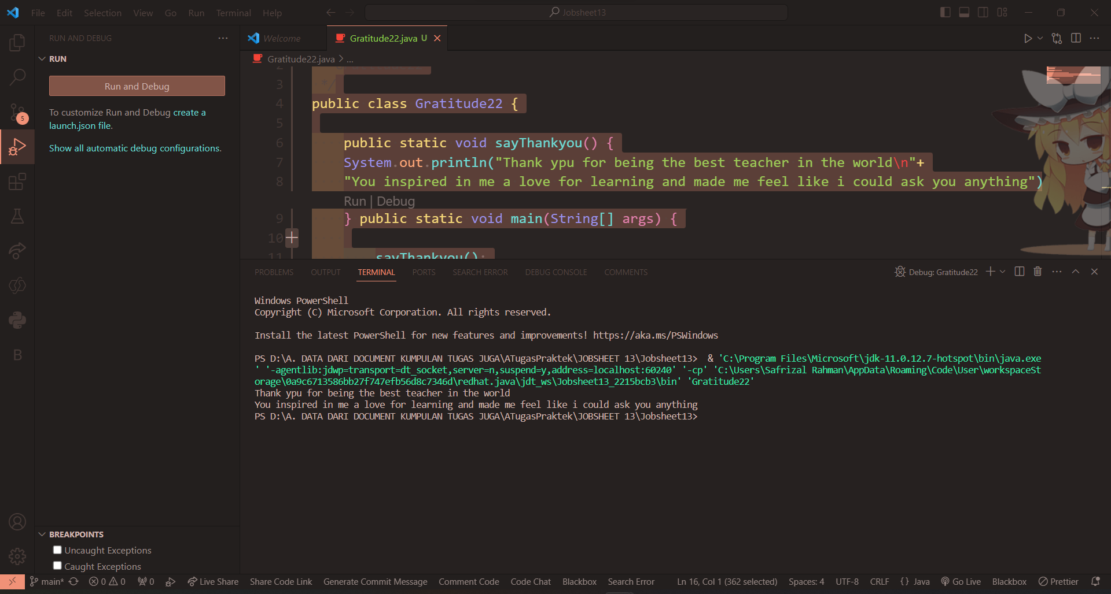

**Question!**

1. Does function with no parameter always have void datatype?

**No, the purpose of the parameter is a variable from the outside, if we can make a variable displacement**

**in the function itself make parameter is not required, danni Lai**

**return / return will match the function declaration**

1. Is it possible for sentence “**Thank you for…..dst**” to be displayed, without using **sayThankyou()** function? Modify the program so that it displays the sentence without using function!

**If we modify the code to be like this**

*/\*\**

*\* Gratitude22*

*\*/*

public class Gratitude22 {

    public static String sayThankyou() {

        String ucapan = "Thank ypu for being the best teacher in the world\n"+

        "You inspired in me a love for learning and made me feel like i could ask you anything"; return ucapan;

    } public static void main(String[]args) {

*// menggunakan fungsi*

    String thankYou = sayThankyou();

    System.out.println(thankYou);

*// tanpa fungsi*

    System.out.println("Thank ypu for being the best teacher in the world\n"+

    "You inspired in me a love for learning and made me feel like i could ask you anything");

    }

}

*//     public static void sayThankyou() {*

*//     System.out.println("Thank ypu for being the best teacher in the world\n"+*

*//     "You inspired in me a love for learning and made me feel like i could ask you anything");*

*//     } public static void main(String[] args) {*

*//         sayThankyou();*

*// }*

*// }*

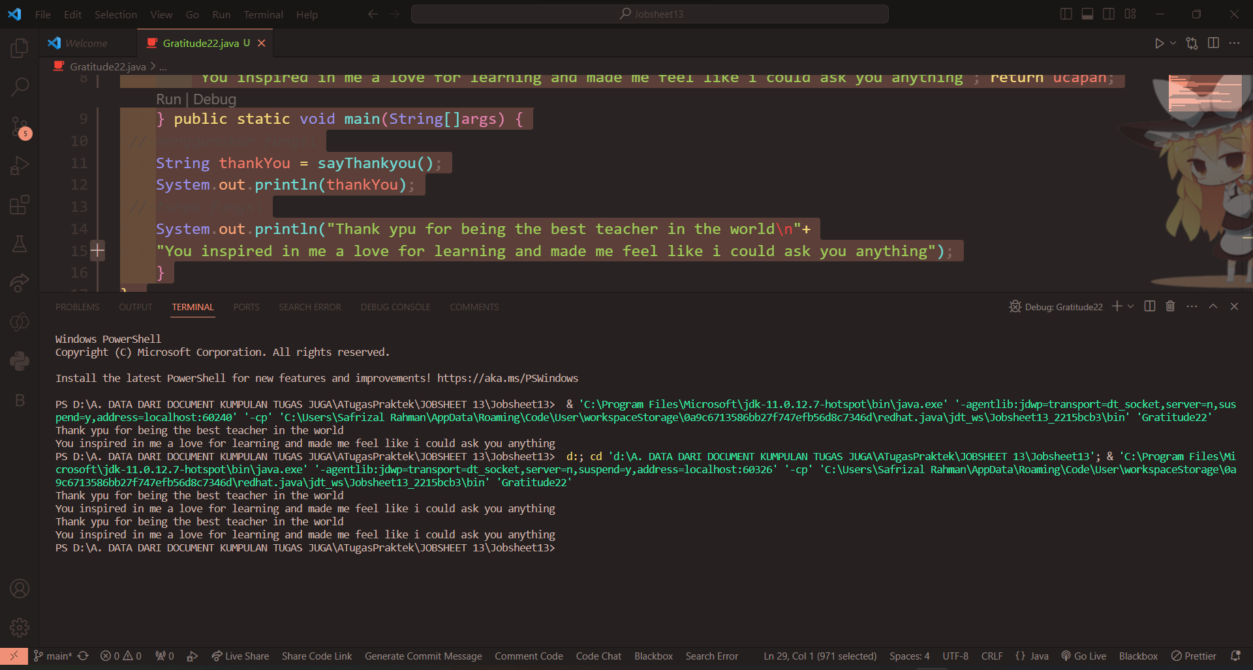

1. What are the benefits of using functions in a program?

**We can use that function many times in other functions without having to rewrite it**

**syntaxmya again and not too complicated keitka want to loop a condition**

**2.2 Experiment 2: Function with Parameters**

# Time: 40 minutes

1. Create a new function named **sayAdditionalGreetings()** that has one parameter with String datatype, in class di dalam *class* **Gratitude_StudentIDNumber.java**!

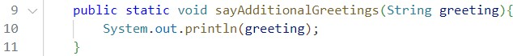

1. Call **sayAdditionalGreetings()** function from ***main***().

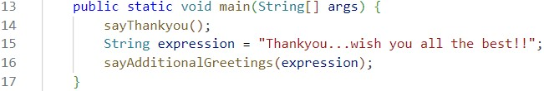

*/\*\**

*\* Gratitude22*

*\*/*

public class Gratitude22 {

    public static String sayThankyou() {

        String greeting = "Thank ypu for being the best teacher in the world\n"+

        "You inspired in me a love for learning and made me feel like i could ask you anything"; return greeting;

    } public static void main(String[]args) {

*// menggunakan fungsi*

    String thankYou = sayThankyou();

    System.out.println(thankYou);

*// tanpa fungsi*

    System.out.println("Thank ypu for being the best teacher in the world\n"+

    "You inspired in me a love for learning and made me feel like i could ask you anything");

        sayThankyou();

        String greeting = "Thankyou Mr...and Mrs... For 1 semester teaching me";

        sayAdditionalGreetings(greeting);

    }

    public static void sayAdditionalGreetings(String greeting) {

        System.out.println(greeting);

        }

}

*//     public static void sayThankyou() {*

*//     System.out.println("Thank ypu for being the best teacher in the world\n"+*

*//     "You inspired in me a love for learning and made me feel like i could ask you anything");*

*//     } public static void main(String[] args) {*

*//         sayThankyou();*

*// }*

*// }*

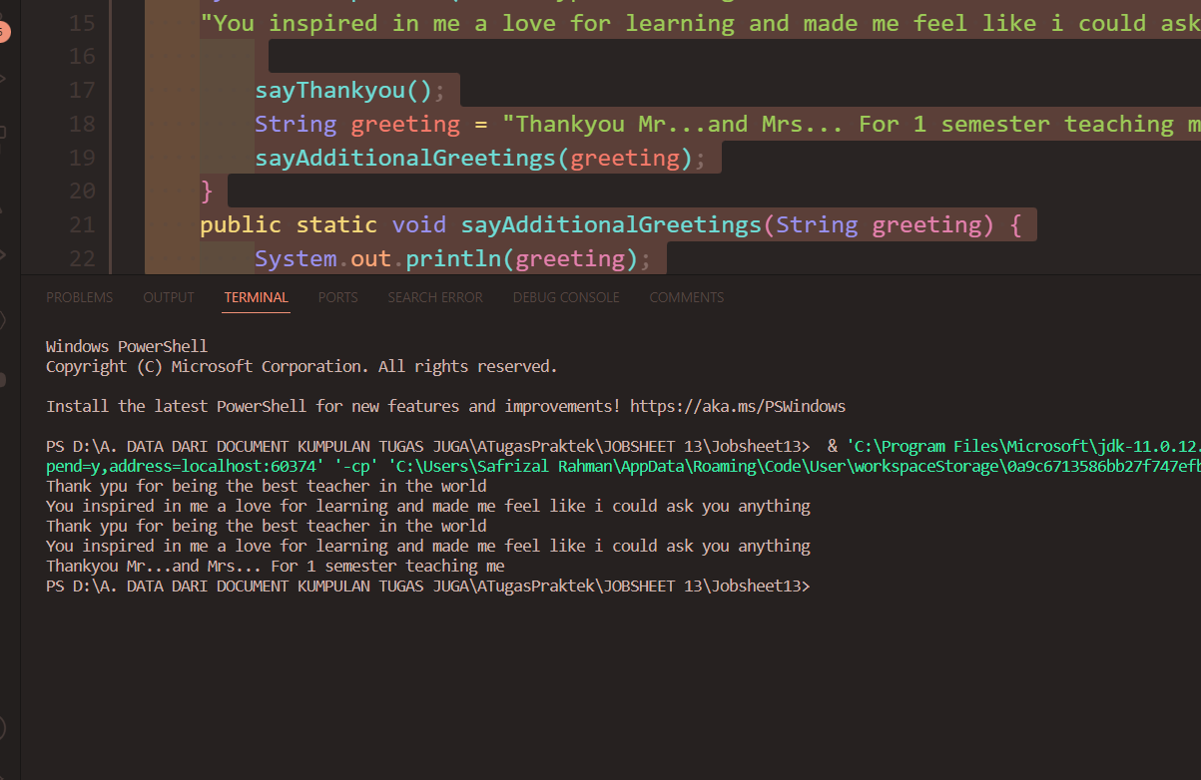

**Question!**

1. What is the use of a parameter in a function?

**So that variables from outside the function can be used as local variables of the function**

1. Is parameter similar to variable? Please explain!

**In summary, a variable is a named storage location in a program, while a parameter is a variable used in a function or method definition to represent the input values. When you call a function, you provide arguments, which are the actual values that match the parameters**

1. In the Java programming language, is parameter only used for passing input data?

What about output data?

**Yes, for Responsible output is return or any other form of output such as**

**System.out.print**

## 2.3 Experiment 3: Function with Return Value Time: 40 minutes

1. Create a new class and save it as **Greetings_StudentIDNumber.java**.
2. Create a new function to get the recipient of the greeting named **getGreetingRecipient()** that will get the name from the user input and will return the name. That is why this method has String datatype and also has return value.

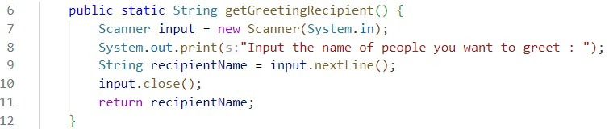

1. Create **main()** function and call **getGreetingRecipient()** function from main!

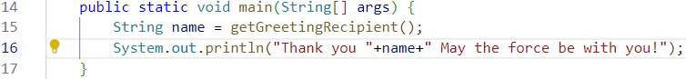

import java.util.Scanner;

public class greeting22 {

    public static String getGreetingRecipient(){

        Scanner sc22 = new Scanner(System.in);

    System.out.println("Write Name Someone You can give Greeting:");

    String someoneName = sc22.nextLine();

    return someoneName;

    } public static void main(String[] args) {

    String name = getGreetingRecipient();

    System.out.println("Thank you "+name+"\nMay the force be with you");

    }

}

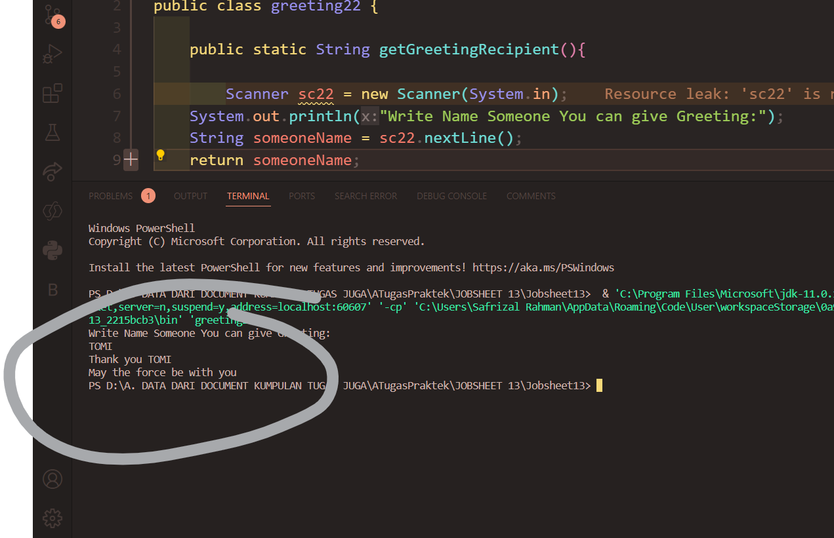

**Question!**

1. Explain when do we need to create a function that requires a return value?

**When we want the value of a function it is stored and will be used in another function**

1. Can a **System.out.println** statement be added inside a function with a return value? What is its impact?

**Yes, but only if you use the System.out.println we can not menimpanyan in**

**a variable**

1. Can a function without a return value be called inside the main function without being passed to a variable? Like in experiment 1? Explain!

**Could be because in Experiment 1 the function uses Sytem.out.println when the function**

**called then it will do what is in the function that is printing thanks....dsb**

**Experiment 4:**

## 2.4 Experiment 4: Calling Function from the Other Function Time: 50 minutes

1. Create a new class and name it as **ExpressingGratitude_StudentIDNumber.java**. In this class, we will attempt to combine the functions that we have previously created in the **Gratitude** and **Greetings** classes.
2. Create **getGreetingRecipient()** function, that will return the recipient’s name after getting the input from the user.

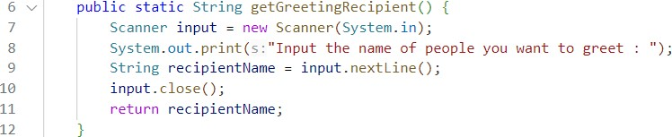

1. Create **sayThankyou()** function, in this function, get the recipient for the greeting by calling **getGreetingRecipient()** function. The recipient will be included in the thank you expression (sentence).

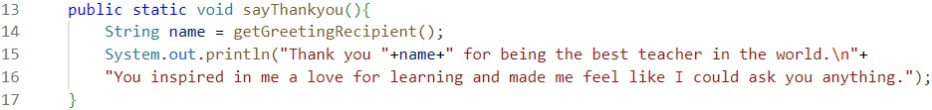

1. Create **main()** function and call **sayThankyou()** function from there.

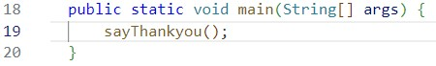

import java.util.Scanner;

public class ExpressingGratitude22 {

    public static String getGreetingRecipient(){

    Scanner sc = new Scanner(System.in);

    System.out.println("Write Name Someone You can give Greeting:");

    String namaOrang = sc.nextLine(); sc.close();

    return namaOrang;

    }

        public static void sayThankyou() {

        String nama = getGreetingRecipient();

        System.out.println("Thank you "+nama+" for being the best teacher in the world\n"+

        "You inspired in me a love for learning and made me feel like i could ask you anything");

    } public static void main(String[] args) {

    sayThankyou();

    }

}

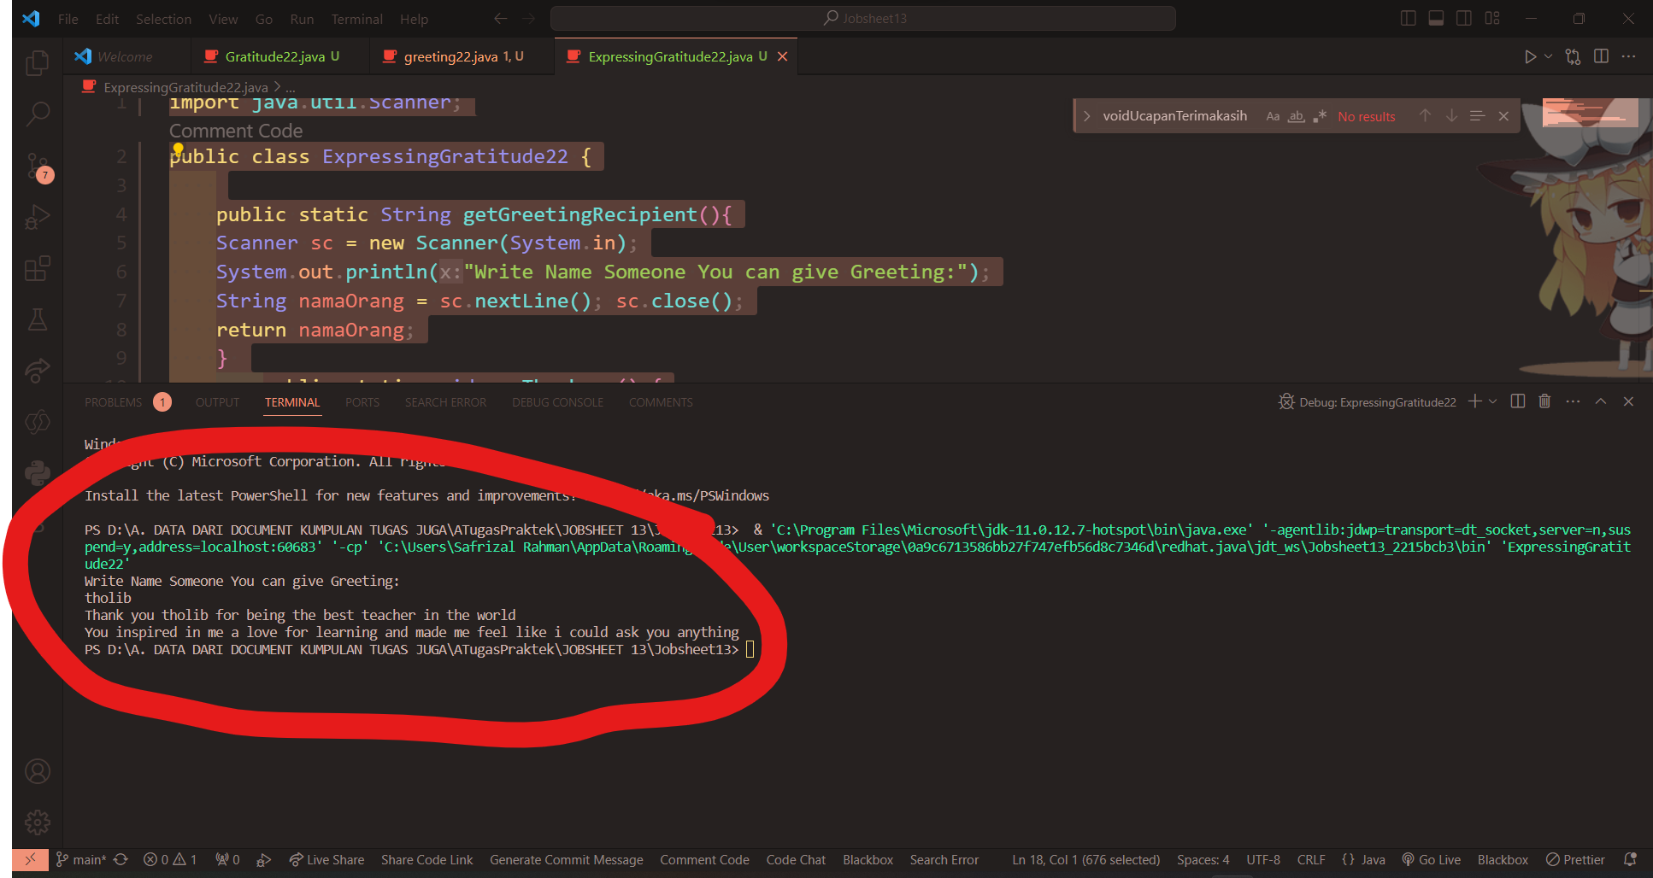

**Question!**

1. Based on experiment 4, which function will execute first? Please explain!

**Starts from main and then main () calls the function say thank you () and then inside the function**

**Acknowledgements () call the function Receiveaccept (), run Receiveaccept ()**

**before I say thank you...D.C., where they say thank you**

1. Which is the correct way to write a function inside a class? Above the main function or below the main function? Please explain!

**Free because it does not affect the program, the main function will definitely be run first**

**even if it's on the last line**

1. Modify the above program by adding the function **sayAdditionalGreetings**() with a String input parameter. The **sayAdditionalGreetings**() function contains additional remarks or greetings that you want to convey to the greeting recipient.
2. import java.util.Scanner;
3. public class ExpressingGratitude22 {
5. public static String getGreetingRecipient(){
6. Scanner sc = new Scanner(System.in);
7. System.out.println("Write Name Someone You can give Greeting:");
8. String namaOrang = sc.nextLine(); sc.close();
9. return namaOrang;
10. }
11. public static void sayThankyou() {
12. String nama = getGreetingRecipient();
13. System.out.println("Thank you "+nama+" for being the best teacher in the world\n"+
14. "You inspired in me a love for learning and made me feel like i could ask you anything");
16. } public static void main(String[] args) {
17. sayThankyou();
18. String nama = getGreetingRecipient();
19. String greeting = "Thank you "+nama+" wish you all the best";
20. greetingAdd(greeting);
22. }
23. public static void greetingAdd(String greeting) {
24. System.out.println(greeting);
25. }
26. }

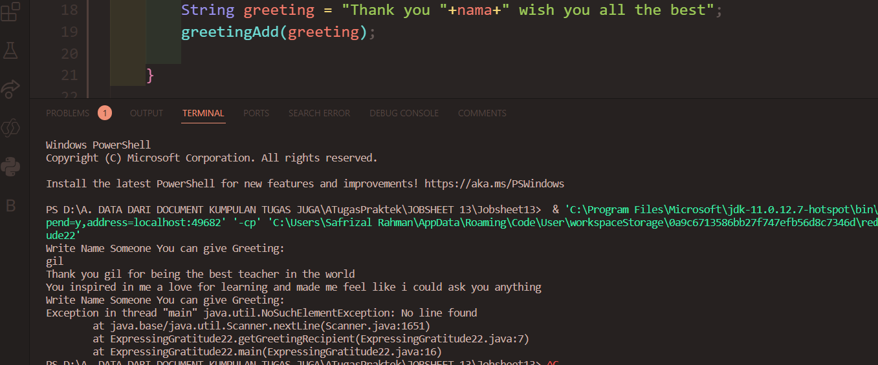

## 2.5 Experiment 5: Variable Arguments (Varargs) Time: 40 minutes

1. Create a new class and name it as **Experiment5_StudentIDNumber.java**.
2. Create **show()** function that has **void** datatype, and has 2 parameters with **String** dan **int** datatype

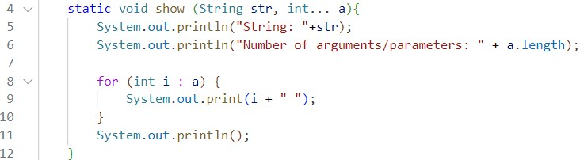

1. Create **main** function and call **show**() function from there.

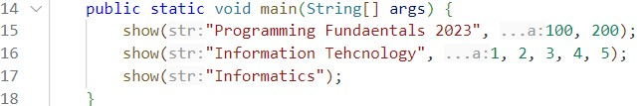

public class Experiment522 {

    static void show(String str, int... a){

    System.out.println("String: "+str);

    System.out.println("Total argunem/parameter: "+ a.length);

for (int i : a) {

    System.out.print(i+" ");

    }

        System.out.println();

    } public static void main(String[]args) {

    show("Daspro 2023 © SAPRII", 100,200);

    show("Bussines Information System", 1,2,3,4,5);

    show("Polythecnyc Malang");

    }

}

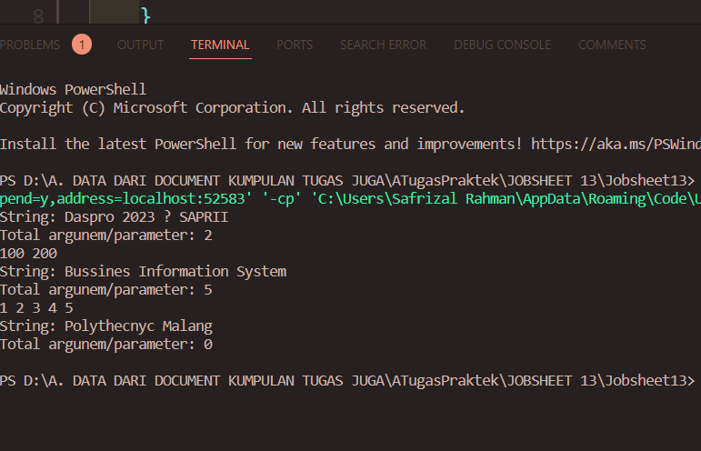

**Question!**

1. Explain why the parameter in experiment 5 is written as **int... a**!

**Because There are Variable arguments**

1. Mention the example of varargs in implementing code to solve real-world problems! (at least 3)

**\* Finding the average**

**\* Mathematical operations**

**\* Print a list of names**

1. Can we use two different data types for varargs in one function? Provide an example!

**Can not, because in the first and subsequent parameters will always be a variable**

**normally only the last parameter can be variable arguments**

## 2.6 Experiment 6: Writing Code, with and without Function Time: 50 minutes

1. Create a new class and name it as **Experiment6_StudentIDNumber.java**.
2. Create a program to calculate the area of rectangle and volume of cube, without using function!

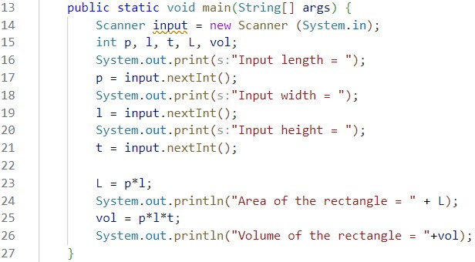

1. The above code, if we implement using function, there will be at least 3 functions:

**calculateArea**, **calculateVolume** and **main** function.

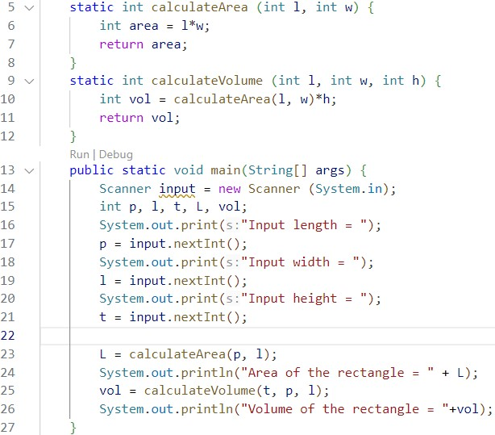

1. Run the program and write down the result you got!
2. import java.util.Scanner;
3. public class Experiment622 {
4. static void Luas(int p,int l){
5. int luas=p*l;
6. System.out.println("Square Area Is "+luas);
7. }   static void Volume(int p,int l,
8. int t){ int vol = p*l*t;
9. System.out.println("Beam volume is "+vol);
10. }   public static void main(String[] args) { Scanner sc = new
11. Scanner(System.in);
12. System.out.print("enter length : ");
13. int p=sc.nextInt();
14. System.out.print("enter width : ");
15. int l=sc.nextInt();
16. System.out.print("enter height : ");
17. int t =sc.nextInt();
18. Luas(p, l);
19. Volume(p, l, t);
20. }
21. }

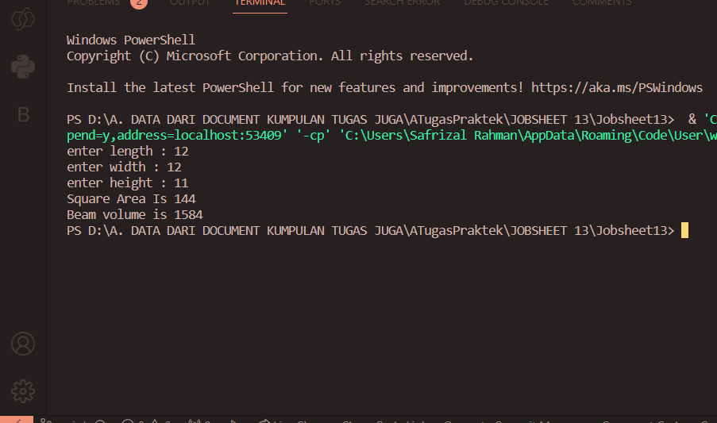

**Question!**

1. Explain the execution steps for experiment 6 above!

**Starting from the main function in which it inputs the value of p,l, t and then calls the broad function**

**parameter int p, int l in which multiplies p and l and then stored in a wide variable**

**and print the area and then go back to main and call the volume function with parameter int p,**

**int l, int t in which will multiply the variables p, l, and t and then stored in the variable vol**

**then print vol**

1. What is the output of the program below, then explain the steps of the program!

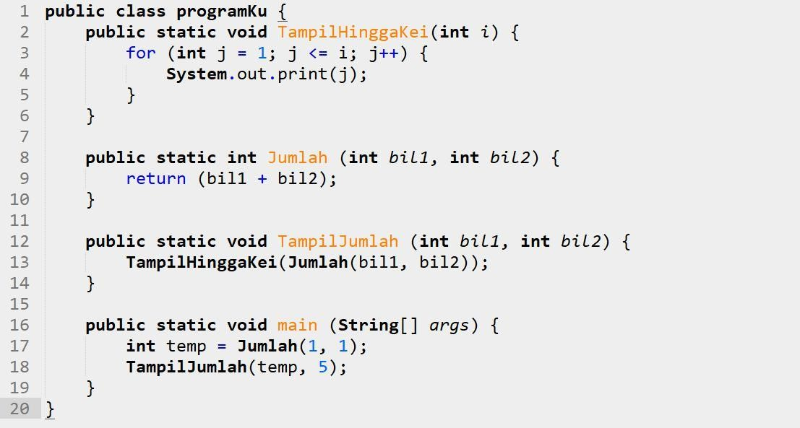

**- The output is 1234567**

**- The flow must be started from play and then play calls the number function which will add**

**1+1 and the result will be stored in temp which is value 2, then main call the function**

**Shownumber with parameters 2 and 5 and in the Shownumber function is called**

**Appearinghinggakei but because the parameter is a function of the sum of the sum function in**

**run it first so that it is 2+5 then the parameter from Showinghinggakei is 7. then loop**

**inside the function will print 1-7**

1. When do we need to create a function with and without parameters? When do we need to create a function with and without return value? Explain!

**Using parameters when we need variables from outside**

**We use the return value when it needs to be saved**

# 3. Assignment Time: 100 minutes

1. Create a new class named **CubeStudentIDNumber** that has function to calculate area and volume!
2. Create a program to manage the weekly grades (there are 7 weeks) of 5 students.

The data must be implemented using 2 dimensional array as follows:

|  |  |  |  |  |  |  |  |
| --- | --- | --- | --- | --- | --- | --- | --- |
|  | **Week 1** | **Week 2** | **Week 3** | **Week 4** | **Week 5** | **Week 6** | **Week 7** |
| **Sari** | 20 | 19 | 25 | 20 | 10 | 0 | 10 |
| **Rina** | 30 | 30 | 40 | 10 | 15 | 20 | 25 |
| **Yani** | 5 | 0 | 20 | 25 | 10 | 5 | 45 |
| **Dwi** | 50 | 0 | 7 | 8 | 0 | 30 | 60 |
| **Lusi** | 15 | 10 | 16 | 15 | 10 | 10 | 5 |

Add functions to retrieve information from the above data with the following details:

* 1. Function to input students’ grade data.
  2. Function to display all student grades from the first week to the seventh week.
  3. Function to find the week that has the highest grade from all students.
  4. Function to find the student with the highest grade (also display the grade information for each week).

1. Modify assignment number 2 above by getting the user input to determine the number of students and the number of weeks!
2. import java.util.Scanner;
3. public class cube22 {
4. static void Volume(int s){
5. int vol = s*s*s;
7. System.out.println("Volume Cube : "+vol);
8. } static void Extensibility(int s){
9. int Extensibility=s*s*6;
10. System.out.println("The surface area of the cube is :"+Extensibility);
11. } public static void main(String[]args) { Scanner sc = new
12. Scanner(System.in);
13. System.out.print("Enter the length of the side of the cube :"); int sisi=sc.nextInt(); Volume(sisi);
14. Extensibility(sisi);
15. }
16. }

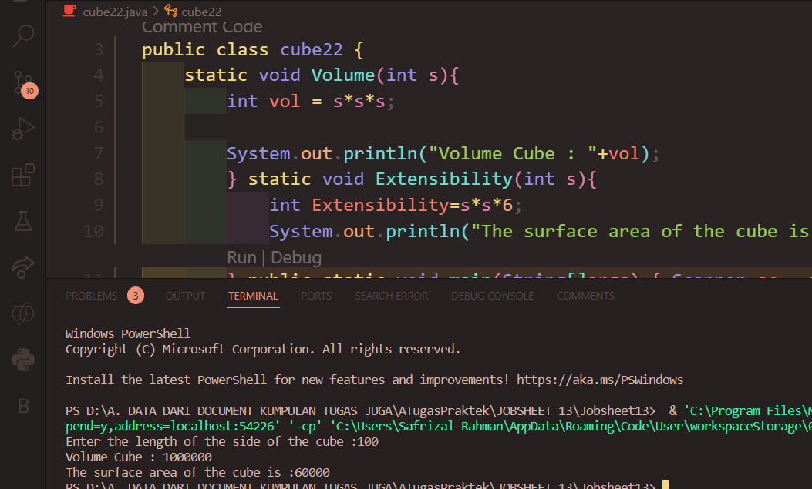

# Group Assignment

Implement the function into your group project. Don't forget, make sure the source code is pushed to your repository.

import java.text.SimpleDateFormat;

import java.time.LocalDateTime;

import java.util.Date;

import java.util.Scanner;

public class Expedition {

static Scanner scanner = new Scanner(System.in);

// Declaration Login

static int usign = 3, psign = 3;

static String[] Log = { "Safrizal", "Naufal", "Vahira", "Tarno" };

static String[] pass = { "Admin1", "Admin2", "Admin3", "Admin4" };

static boolean signUp = false, login = false, menuLog = false, menu = true, lagi = true;

static String namaLog = "", passLog, date = "", again, namaSignup, passSignup = "", passSignup1;

static int option, repreat = 0, user = -1;

static int userChoice;

// Array Kota dan harga

static String[][] perkiraan = {

{ "Surabaya", "Malang", "100", "12000" },

{ "Surabaya", "Jakarta", "780", "14000" },

{ "Surabaya", "Pasuruan", "70", "10000" },

{ "Malang", "Surabaya", "100", "12000" },

{ "Malang", "Jakarta", "850", "21000" },

{ "Malang, Pasuruan", "75", "10000" },

{ "Jakarta", "Malang", "850", "21000" },

{ "Jakarta", "Surabaya", "780", "14000" },

{ "Jakarta", "Pasuruan", "820", "22000" },

{ "Pasuruan", "Malang", "75", "10000" },

{ "Pasuruan", "Surabaya", "70", "10000" },

{ "Pasuruan", "Jakarta", "820", "22000" },

};

// int[] perkiraanharga = {{ }};

// untuk Input

static String fromWhere = "";

static String toWhere = "";

static String paymenType = "";

static String formattedDate = "";

static String expeditionName = "";

static String recipientName = "";

static String inputDate = "";

static String anything = "";

// static String Recieve = "";

static int totalGoods = 0, weight = 0, day = 0;

static int startDate = 0, endDate = 0;

static double totalDistance = 0.0, rangeTime = 0.0, distanceCost = 0.0;

static double costPerTime = 0.0, totalCost = 0.0, costPerKilometer = 0.0;

static void SignUp() {

System.out.println("|========================================|");

System.out.println(" Sign Up ");

System.out.println("|========================================|");

System.out.printf("Apply the username : ");

namaSignup = scanner.next();

if (namaSignup.length() < 3) {

ClearScreen();

System.out.println("Minimum 3 text ");

SignUp();

}

for (int i = 0; i < usign; i++) {

if (namaSignup.equals(Log[i])) {

System.out.println("Username has loged in on another account");

SignUp();

}

}

System.out.print("Type password : ");

passSignup1 = scanner.next();

System.out.print("Repeat password : ");

passSignup = scanner.next();

if (passSignup.equals(passSignup1)) {

String[] newNama = new String[usign + 1];

usign++;

for (int i = 0; i < Log.length; i++) {

newNama[i] = Log[i];

}

Log = newNama;

String[] newPass = new String[psign + 1];

psign++;

for (int i = 0; i < pass.length; i++) {

newPass[i] = pass[i];

}

pass = newPass;

Log[usign - 1] = namaSignup;

pass[psign - 1] = passSignup;

ClearScreen();

System.out.println("Your account has been succes registered ");

Login();

} else {

ClearScreen();

System.out.println("The password is not syncron !!!");

SignUp();

}

}

static void Login() {

user = -1;

System.out.println(" |========================================|");

System.out.println("| Login |");

System.out.println(" |========================================|");

System.out.printf("Input username : ");

namaLog = scanner.next();

for (int i = 0; i < Log.length; i++) {

if (namaLog.equals(Log[i])) {

user = i;

break;

}

}

System.out.print("Input Password : ");

passLog = scanner.next();

if (user == -1) {

ClearScreen();

System.out.println("wrong username or password ");

Login();

}

if (passLog.equals(pass[user])) {

ClearScreen();

MainMenu();

} else {

System.out.print("\033[H\033[2J");

System.out.println("wrong username or password");

}

}

static void MenuInput() {

System.out.println("Welcome to the Expedition Java Application!");

System.out.print("Please enter the sender name: ");

expeditionName = scanner.nextLine();

System.out.print("Please enter the recipient name: ");

recipientName = scanner.nextLine();

// System.out.print("Please enter the start date (DD-MM-YYYY): ");

// startDate = scanner.nextInt();

// System.out.print("Please enter the end date (DD-MM-YYYY): ");

// endDate = scanner.nextInt();

ClearScreen();

System.out.println("|=========================================| ");

System.out.println("Malang");

System.out.println("Surabaya");

System.out.println("Jakarta");

System.out.println("Pasuruan");

System.out.println("|=========================================| ");

System.out.print("From where : ");

fromWhere = scanner.nextLine();

ClearScreen();

System.out.println("|=========================================| ");

System.out.println("Malang");

System.out.println("Surabaya");

System.out.println("Jakarta");

System.out.println("Pasuruan");

System.out.println("|=========================================| ");

System.out.print("To Where : ");

toWhere = scanner.nextLine();

int row = 0;

for (int i = 0; i < perkiraan.length; i++) {

for (int j = 0; j < perkiraan[i].length; j++) {

if (perkiraan[i][j].equalsIgnoreCase(fromWhere)) {

if (perkiraan[i][j + 1].equalsIgnoreCase(toWhere)) {

row = i;

}

}

}

}

totalDistance = Double.parseDouble(perkiraan[row][2]);

// menampilkan tanggal sekarang

Date currentDate = new Date();

LocalDateTime localDateTime = LocalDateTime.now();

day = localDateTime.getDayOfMonth();

SimpleDateFormat format = new SimpleDateFormat("dd/MM/yyyy");

formattedDate = format.format(currentDate);

System.out.println("Date Now : " + formattedDate);

// menginput tanggal perkiraan

System.out.print("Enter an estimation date (dd/MM/yyyy) : ");

inputDate = scanner.nextLine();

// mengubah tanggal perkiraan dari String ke Date

SimpleDateFormat inputDateFormat = new SimpleDateFormat("dd/MM/yyyy");

try {

Date expectedDate = inputDateFormat.parse(inputDate);

System.out.println("The estimation dates for shipping the goods is : " + expectedDate);

} catch (Exception e) {

System.out.println("Incorrect date Format entered.");

}

ClearScreen();

System.out.print("Please enter Range Time days : ");

rangeTime = scanner.nextDouble();

scanner.nextLine(); // Consume newline

System.out.print("Please enter the weight of Goods: ");

weight = scanner.nextInt();

scanner.nextLine();

System.out.print("Please enter the total number of Goods: ");

totalGoods = scanner.nextInt();

scanner.nextLine();

distanceCost = Double.parseDouble(perkiraan[row][3]);

// Calculations kilogrma

int costPerKg = 4000; // fixed price reference by JNE

//weight = 10kg

//totalGoods = 2

//distanceCost = 12000

// simulation = 4000 * (10 * 2) + 12000

totalCost = costPerKg * (totalGoods * weight) + distanceCost;

ClearScreen();

MainMenu();

}

static void NewPass() {

System.out.print("Input New Password: ");

String newPass = scanner.next();

pass[user] = newPass;

System.out.println("Password changed successfully!");

MainMenu();

}

static void Account() {

System.out.println("Username: " + Log[user]);

System.out.println("Password: " + pass[user]);

System.out.println("Insert anything to go back");

anything = scanner.nextLine();

}

static void Detail() {

System.out.println("\nExpedition Details + Payment:");

System.out.println("Name: " + expeditionName);

System.out.println("Start Date: " + formattedDate);

System.out.println("Range Time : " + rangeTime);

System.out.println("End Date: " + inputDate);

System.out.println("Total Distance (km): " + totalDistance);

System.out.println("Cost Distance: " + distanceCost);

System.out.println("weight of good: " + weight);

System.out.println("Total Goods: " + totalGoods);

System.out.println("Total Cost: " + totalCost);

System.out.println("|=========================================| ");

System.out.println("| Payment |");

System.out.println("|=========================================| ");

System.out.print("Payment type (Direct / COD) : ");

String paymentType = scanner.nextLine();

Double paymentAmount = 0.0;

Double remain = 0.0;

if(paymentType.contains("COD")) {

System.out.println("|=========================================| ");

System.out.println("| Payment : Not yet paid off |");

System.out.println("|=========================================| ");

} else {

System.out.print("Payment amount : ");

paymentAmount = scanner.nextDouble();

remain = paymentAmount - totalCost;

System.out.println("|=========================================| ");

System.out.println("| Payment : Paid off |");

System.out.println("| |");

System.out.println("| Remain fee : Rp. "+remain+"|");

System.out.println("|=========================================| ");

}

ClearScreen();

System.out.println("Insert anything to go back");

anything = scanner.nextLine();

MainMenu();

}

static void Recieve(){

System.out.println("|=========================================| ");

System.out.println("| Resi : Express"+getAlphaNumericString(7)+ "|");

System.out.println("|=========================================| ");

System.out.println("Sender Name: " + expeditionName);

System.out.println("Cost Distance: " + distanceCost);

System.out.println("weight of good: " + weight);

System.out.println("Total Goods: " + totalGoods);

System.out.println("Total Cost: " + totalCost);

System.out.println("|=========================================| ");

System.out.println("Recipient Name: " + recipientName);

System.out.println("From: " + fromWhere);

System.out.println("To: " + toWhere);

System.out.println("|=========================================| ");

// System.out.println( paymentType = "");

String paymentType = scanner.nextLine();

System.out.println("| Shipment Type : "+paymentType+ "|");

System.out.println("|=========================================| ");

}

static String getAlphaNumericString(int n)

{

// choose a Character random from this String

String AlphaNumericString = "ABCDEFGHIJKLMNOPQRSTUVWXYZ"

+ "0123456789"

+ "abcdefghijklmnopqrstuvxyz";

// create StringBuffer size of AlphaNumericString

StringBuilder sb = new StringBuilder(n);

for (int i = 0; i < n; i++) {

// generate a random number between

// 0 to AlphaNumericString variable length

int index

= (int)(AlphaNumericString.length()

* Math.random());

// add Character one by one in end of sb

sb.append(AlphaNumericString

.charAt(index));

}

return sb.toString();

}

static void Additional() {

System.out.println("\nAdditional Information:");

if (totalDistance > 1000) {

System.out.println("This is a long expedition!");

} else {

System.out.println("This is a short expedition.");

}

if (totalGoods > 50) {

System.out.println("Large group! Special arrangements may be needed.");

} else {

System.out.println("Manageable group size.");

}

if (costPerKilometer > 2.5) {

System.out.println("The expedition may be costly.");

} else {

System.out.println("The expedition is reasonably priced.");

}

System.out.println("Insert anything to go back");

anything = scanner.nextLine();

MainMenu();

}

static void MainMenu() {

System.out.println("|=========================================|");

System.out.println("| Logged In Menu |");

System.out.println("|=========================================|");

System.out.println("| 1. Go to Option Menu |");

System.out.println("| 2. Change Password |");

System.out.println("| 3. View Account Info |");

System.out.println("| 4. Detail & Payment |");

System.out.println("| 5. View additional information|");

System.out.println("| 6. Print Recieve |");

System.out.println("| 6. Logout |");

System.out.println("|=========================================| ");

System.out.printf("Choose an option: ");

userChoice = scanner.nextInt();

scanner.nextLine();

switch (userChoice) {

case 1:

ClearScreen();

MenuInput();

case 2:

ClearScreen();

NewPass();

case 3:

ClearScreen();

Account();

case 4:

ClearScreen();

Detail();

case 5:

ClearScreen();

Additional();

case 6:

ClearScreen();

Recieve();

case 7:

Run();

default:

ClearScreen();

System.out.println("Wrong input");

MainMenu();

}

}

static void ClearScreen() {

System.out.print("\033[H\033[2J");

System.out.flush();

}

static void Run() {

System.out.println("|========================================|");

System.out.println(" ");

System.out.println(" EXPEDITION ");

System.out.println(" ");

System.out.println("|========================================|");

System.out.println("1. SignUp First if you dont have account");

System.out.println("2. Login If you Have an account Before");

option = scanner.nextInt();

ClearScreen();

switch (option) {

case 1:

SignUp();

case 2:

Login();

default:

System.out.println("Wrong input");

Run();

}

}

public static void main(String[] args) {

ClearScreen();

Run();

}

}